Additional Pay Pre-Approval Request Form

Penn ID Employee Name (last name, first name)
Is this employee a Wharton employee?
Yes No

Employee Org# Employee School and Dept Name Period of Service Begin Date Period of Service End Date
Note: Payments to Wharton staff for duties performed during normal working hours require verification that PTO was taken.
Enter the time and # of hours during the day the work will occur:
Earnings:

Requested Earnings Amount; or Requested Earnings Range Amount (if multiple payments)
Funding (Percentages must add to 100% if multiple funding sources.)
Percent Org # CNAC Fund Program CREF

Additional Comments:

Nature of Service

Sponsoring Department/School Sponsoring Manager

Employee’s manager’s signature _____________________________________

Description of responsibilities (please be specific, including estimated hours):

Employee Certification

Before committing to any activity outside of normal working duties, a monthly paid employee is required to secure written approval from their manager. Approval must be sought for any commitment outside the employee’s regular job duties for which the employee would receive compensation, including but not limited to consulting, corporate directorship or retainers, and teaching (whether for the University of Pennsylvania or another institution; includes for-credit-courses and executive education). If duties involve working during the employee’s regular workday, the employee must use PTO or forego additional compensation unless prior approval has been secured from the Senior Director of Wharton Human Resources. To request a waiver, attach a brief memo explaining the reason for an exception.

Approval to assume extramural activity must be secured from the individual’s supervisor and Senior Director of Human Resources before the activity begins. This form will act as supporting documentation for that approval through Workday.

_______________________________________ _____________________________________
Employee signature Date

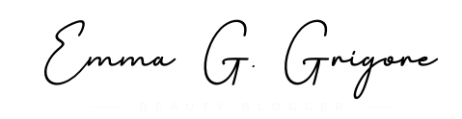

_______________________________________ _____________________________________
Wharton HR signature Date

